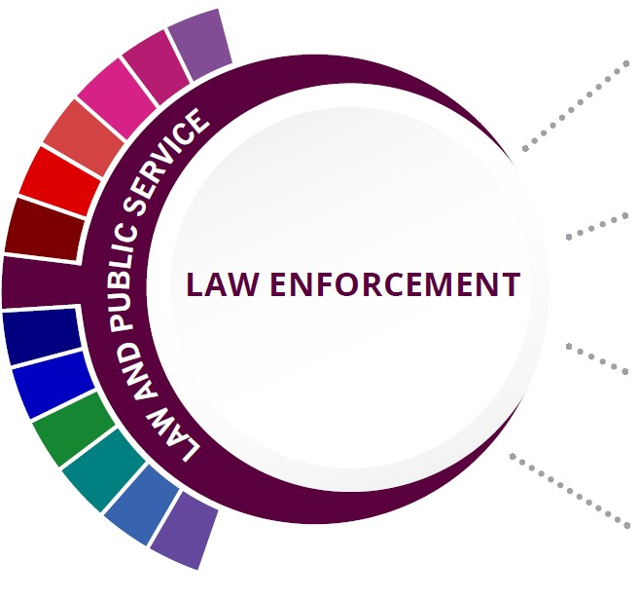
Statewide Program of Study: Law Enforcement; Public Service Career Cluster
Level 1 | Principles of Law, Public Safety, Corrections, and Security
Level 2 | Law Enforcement I
Level 3 | Law Enforcement II  Correctional Services
Level 4 | Forensic Science

HIGH SCHOOL/ INDUSTRY CERTIFICATION | CERTIFICATE/ LICENSE* | ASSOCIATE’S DEGREE | BACHELOR’S DEGREE | MASTER’S/ DOCTORAL PROFESSIONAL DEGREE
Non-Commissioned Security Officer Level II | Law Enforcement Officer | Criminal Justice/Safety Studies/Law Enforcement Administration | Criminal Justice/Safety Studies/Law Enforcement Administration | Criminal Justice/Safety Studies/Law Enforcement Administration
Emergency Telecommunicator | Private Investigator/ Security Guard | Criminal Justice/ Police Science | Criminal Justice/ Police Science | Natural Resources Law Enforcement and Protective Services
 | Code Enforcement Officer | Corrections | Juvenile Corrections
 | Certified Law Enforcement Planner | Criminalistics and Criminal Science | Cyber/ Computer Forensics and Counterterrorism
Additional industry-based certification information is available on the TEA CTE website. For more information on postsecondary options for this program of study, visit TXCTE.org.
Occupations | Median Wage | Annual Openings | % Growth
Police and Sheriff's Patrol Officers | $60,112 | 5,241 | 13%
Probation Officers and Correctional Treatment Officers | $44,054 | 793 | 9%
Correctional Officers and Jailers | $40,186 | 4,683 | 9%
Immigration and Customs Inspectors | $78,104 | 1,236 | 9%
First-Line Supervisors of Police and Detectives | $91,312 | 253 | 25%

WORK BASED LEARNING AND EXPANDED
LEARNING OPPORTUNITIES
Exploration Activities: | Work Based Learning  Activities:
Texas Public Service Association; criminal justice clubs | Attend court hearings and other legal procedures

The Law Enforcement program of study teaches CTE learners about the development of, adherence to, and protection of various branches of law. Students will learn how to appropriately and legally respond to breaches in the law according to statutory rules and regulations as well as investigate how and why the breaches occurred.
The Law and Public Service Career Cluster focuses on planning, managing, and providing legal services, public safety, and homeland security, including professional and technical support services. Students will examine the roles and responsibilities of police, courts, corrections, private security, and protective agencies of fire and emergency services.

Successful completion of the Law and Public Service program of study will fulfill requirements of the Public Service Endorsement. Revised - July 2020

COURSE INFORMATION

COURSE  NAME | SERVICE ID | PREREQUISITES (PREQ)  COREQUISITES (CREQ) | Grade
Principles of Law, Public Safety, Corrections, and Security | 13029200 (1 credit) | None | 9-12
Law Enforcement I | 13029300 (1 credit) | None | 10-12
Law Enforcement II | 13029400 (1 credit) | None | 10-12
Correctional Services | 13029700 (1 credit) | None | 10-12
Forensic Science | 13029500 (1 credit) | PREQ: Biology and Chemistry | 11-12

FOR ADDITIONAL INFORMATION ON THE LAW AND PUBLIC SERVICE CAREER CLUSTER, PLEASE CONTACT:
Dale Fowler | Dale.Fowler@tea.texas.gov
https://tea.texas.gov/cte

(District) offers career and technical education programs in (types of programs offered). Admission to these programs is based on (admission standards). It is the policy of (District) not to discriminate on the basis of race, color, national origin, sex or handicap in its vocational programs, services or activities as required by Title VI of the Civil Rights Act of 1964, as amended; Title IX of the Education Amendments of 1972; and Section 504 of the Rehabilitation Act of 1973, as amended. It is the policy of (District) not to discriminate on the basis of race, color, national origin, sex, handicap, or age in its employment practices as required by Title VI of the Civil Rights Act of 1964, as amended; Title IX of the Education Amendments of 1972; the Age Discrimination Act of 1975, as amended; and Section 504 of the Rehabilitation Act of 1973, as amended. (District) will take steps to assure that lack of English language skills will not be a barrier to admission and participation in all educational and vocational programs. For information about your rights or grievance procedures, contact the Title IX Coordinator at (physical address of Coordinator) (email address of Title IX Coordinator), (phone number of Title IX Coordinator), and the Section 504 Coordinator at (physical address of Coordinator), (email address of Section 504 Coordinator), (phone number of Section 504 Coordinator)

